**Analysing Agriculture in India and making strategic decisions based on it according to population.**

**TEAM NAME:** INNOV8

**TEAM MEMBERS LIST:**

* RAGUL R ___________________________ragulr.21it@sonatech.ac.in
* BRINDHA S_________________________brindha.21ads@sonatech.ac.in
* VISHAL V___________________________vishalv.21it@sonatech.ac.in

**COLLEGE NAME:** SONA COLLEGE OF TECHNOLOGY



**Introduction**

Agriculture, often referred to as the backbone of a nation, is a sector that sustains life, livelihoods, and economies. In the diverse tapestry of India, agriculture plays a pivotal role, providing sustenance to millions, shaping landscapes, and influencing the nation's socio-economic fabric. Harness the full potential of this vital sector and address the myriad challenges it faces, our team, Innov8, embarked on a data-driven journey. Empowered by innovative technologies and a wealth of agricultural data, our mission was to decode the intricate patterns governing crop production, yield variations, and regional nuances within India's agricultural landscape.

This comprehensive documentation encapsulates our findings, methodologies, and insights garnered during this journey. It serves as a valuable resource for farmers, policymakers, agricultural researchers, and stakeholders who share our commitment to promoting sustainable agricultural practices, enhancing productivity, and improving the standard of living for the agricultural community. Our documentation unfolds the story of India's agriculture, revealing its strengths, challenges, and boundless potential.

In the pages that follow, you will delve into a rich tapestry of data-driven analyses, interactive charts, and informative maps, all designed to illuminate the path to agricultural prosperity. Each section is meticulously crafted to provide clarity, context, and actionable insights. Whether you seek to understand regional crop production variations, explore the impacts of diversification, or uncover the top-performing districts, this documentation offers a holistic view of India's agricultural landscape.

Join us on this journey through cultivated data, where insights nurture sustainable choices for thriving landscapes. Welcome to a world where agriculture is unveiled, yielding knowledge that empowers informed decisions and transforms India's agricultural future.

**Current State of Agriculture**

**Background:**

India, known for its diverse landscapes, has a rich agricultural history. From the lush green paddy fields of Kerala to the golden wheat fields of Punjab, Indian agriculture is as diverse as its culture. Agriculture contributes significantly to the nation's economy, providing employment to millions of people and serving as the primary source of livelihood for many.

**Objectives:**

Our mission is to decode the intricate patterns governing crop production, uncover hidden dynamics, and empower data-driven decision-making in India's agricultural landscape. We aim to address the unique challenges faced by the Indian agricultural sector while harnessing its full potential. Our objectives are:

* To promote sustainable agricultural practices.
* Enhance productivity.
* Improve the standard of living for farmers.

**Scope of Work:**

Our comprehensive solution incorporates a range of strategies, technologies, and tools to achieve these objectives. We will analyse data, provide real-time insights, and empower farmers with the information they need to make informed decisions about crop management, resource allocation, and marketing. Our scope includes:

* Developing a digital agriculture platform.
* Implementing precision farming techniques.
* Creating a livestock monitoring system.
* Establishing a weather-based crop insurance system.
* Designing a supply chain management system.
* Providing farmer training and education.
* Offering market information and price forecasting.

**Challenges in Indian Agriculture**

**Weather Dependency:**

Indian agriculture heavily relies on weather conditions. Variations in rainfall, temperature, and other climatic factors directly impact crop yields, making agriculture susceptible to unpredictable weather patterns.

**Drought Susceptibility:**

Droughts pose a significant threat to agriculture. For instance, the 2009-2010 drought caused a sharp decline in coconut production in Tamil Nadu, illustrating the sector's vulnerability.

**Water-Scarce Regions:**

Water scarcity is a pressing concern in certain regions. Our proposed solution seeks to address this issue by promoting water-efficient crops and precision irrigation techniques.

**Opportunities for Agricultural Improvement**

**Precision Farming Techniques:**

Implementing precision farming techniques, such as precision irrigation and crop monitoring, offers opportunities to optimize crop yields and reduce waste. This approach utilizes sensors, drones, and satellite imaging for data-driven decision-making.

**Crop Diversification:**

Crop diversification stabilizes production of er the years, minimizing vulnerability to market fluctuations. Our solution promotes diversification as a strategy for sustainable agriculture.

**Technology Integration:**

Our proposed solution integrates innovative technologies, such as drones for crop monitoring, satellite imaging for precision farming, and machine learning algorithms for real-time data analysis.

**Formulating Strategic Interventions**

* **Digital Agriculture Platform:**

The development of a digital agriculture platform will be a cornerstone of our solution. This platform integrates data sources like weather forecasts, soil moisture, crop health, and market prices. It empowers farmers with real-time insights for informed decisions on crop management, resource allocation, and marketing.

* **Precision Farming Implementation:**

We will implement precision farming techniques to optimize crop yields and reduce waste. This includes precision irrigation, precision farming practices, and crop monitoring using sensors, drones, and satellite imaging.

* **Livestock Monitoring System:**

Our solution includes a livestock monitoring system that tracks livestock health and productivity. This system enables data-driven decisions about feeding, breeding, and disease management, enhancing overall farm efficiency.

* **Weather-Based Crop Insurance:**

We will develop a weather-based crop insurance system to provide financial support to farmers in the event of crop failure or damage due to extreme weather conditions. This bolsters farmers' resilience to unforeseen circumstances.

* **Supply Chain Management:**

The proposed supply chain management system connects farmers with buyers, ensuring better pricing and profitability. It streamlines the agricultural supply chain, benefiting both producers and consumers.

* **Farmer Training and Education:**

Our team will provide training and education to farmers on sustainable agricultural practices, including crop rotation, organic farming, and integrated pest management. Knowledge transfer empowers farmers to make informed choices.

* **Market Information and Price Forecasting:**

We will provide market information and price forecasting to farmers, enabling them to make informed decisions about crop sales and pricing. This fosters better market participation and profitability.

**Business and Social Implications**

**Business Implications:**

Our proposed solution has the potential to improve the profitability of farmers, increase the efficiency of supply chain management, and provide new business opportunities in the agricultural sector.

**Social Implications:**

In terms of social implications, our solution has the potential to improve the standard of living for farmers and their families, improve food security, and promote sustainable agricultural practices.

**Technology Architecture**

**IBM Cognos:**

We will use IBM Cognos to develop the digital agriculture platform and provide real-time data analytics and insights to farmers.

**Python:**

Python is used to develop the precision farming, livestock monitoring, and weather-based crop insurance systems.

**Web Framework (Flask/Django):**

A web framework like Flask or Django will be used to develop the supply chain management system and farmer training and education modules.

**Dataset Information and Limitations**

**Dataset Overview:**

The dataset used for this analysis provides valuable insights into agricultural trends. However, it is important to note its limitations. The dataset covers fifty-six varieties of crops, but not all crops cultivated in India are included. Notably, information on crops like tomatoes and brinjals is absent.

**Column Listing:**

The dataset includes the following columns:

* State
* District
* Year
* Season
* Crop
* Area (in hectares)
* Production (in metric tonnes)
* Yield (in kg per hectare)

**Missing Crop Information:**

The absence of certain crops in the dataset limits our analysis. For example, data on potato and onion are present, but details about tomato and brinjal are missing.

**Null Values:**

The dataset contains null values that require manual correction. Despite these limitations, our analytics are based on the provided dataset to offer meaningful insights.

**Data Limitations:**

It is important to note that the dataset lacks data for coconut production in Tamil Nadu for the years 2010 and 2012. This absence of data for these specific years impacts our analysis of coconut production trends in Tamil Nadu. However, we acknowledge these data gaps and have included all available information from the dataset in our analysis to provide comprehensive insights into coconut production in the state.

**Visualizations and Charts**

Throughout our analysis, we have employed various visualizations and charts to convey insights effectively. These visualizations include:

**State-wise Yield Trends**

The State-wise Yield Trends chart provides a comprehensive overview of yield trends across different states in India. By comparing the yields of various crops in different regions, it offers valuable insights into the strengths and variations of agricultural productivity at the state level. This data is crucial for farmers, policymakers, and agricultural stakeholders, as it aids in understanding which states excel in specific crops and can inform strategies for optimizing productivity and resource allocation.

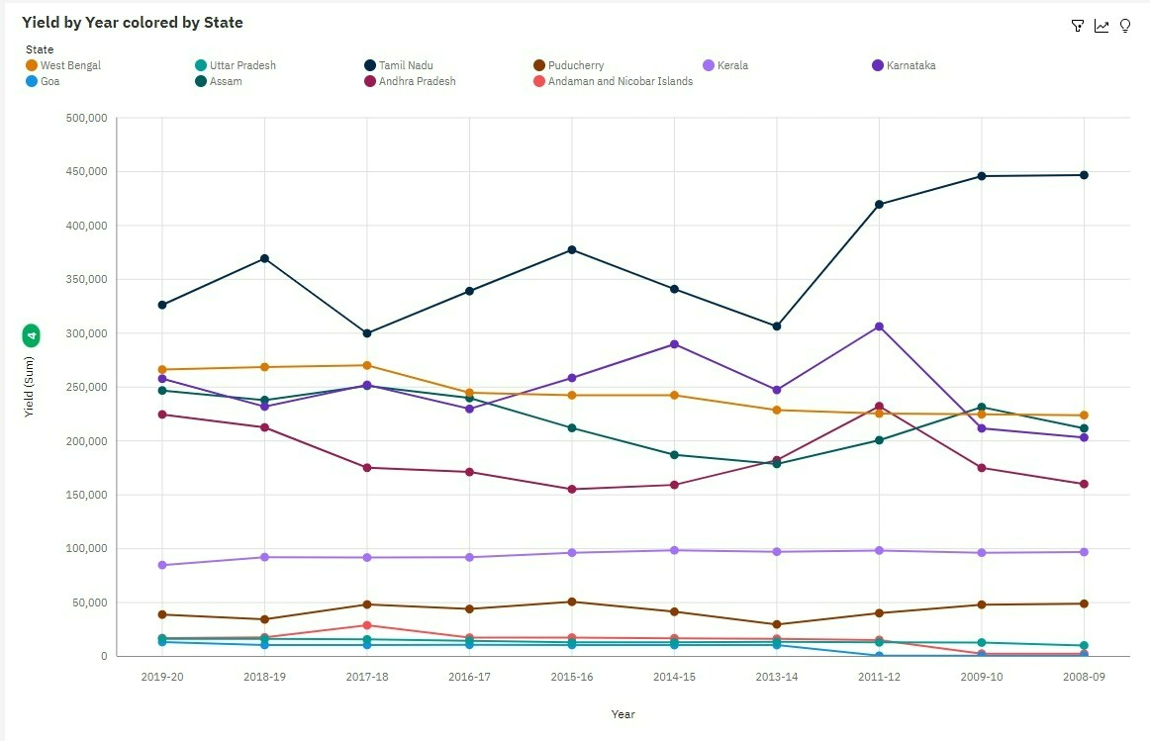

**India's Crop Diversity**

Explore India's crop diversity through this interactive map. It highlights the primary crops grown in each state, offering a quick glance at the country's agricultural variety. This map helps you understand regional strengths and adapt strategies for maximum productivity. Discover the colourful mosaic of India's agriculture and make well-informed decisions.

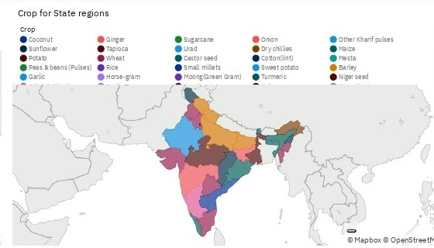.

**Yield Champions**

Delve into the elite ranks of India's agricultural excellence with this chart. It spotlights the top ten districts consistently achieving remarkable crop yields. These districts are the torchbearers of agricultural success, mastering the art of maximizing their land resources.  
Discover the unique elements that underpin their achievements, from favourable climates to pioneering farming methods. This chart unveils the specific crops that flourish in these regions, providing valuable insights for farmers striving to enhance their own yields.  
Whether you are an experienced farmer or a newcomer, these champions offer a concise path to increased productivity and a more prosperous harvest.

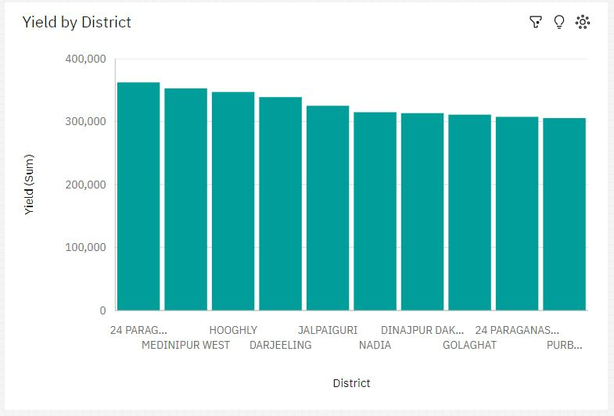

**Crop Harmony: Yielding Insights**

Dive into the harmonious world of crop yields with this insightful chart. It reveals the performance of various crops across different seasons and regions. Explore which crops thrive in specific conditions and when they yield their best results. Uncover the impact of seasons, weather variations, and regional nuances on crop performance.  
This chart is a treasure trove of information for farmers, agricultural researchers, and policymakers. It provides essential knowledge for optimizing planting strategies, resource allocation, and crop selection. Whether your goal is maximum yield or sustainable farming, these yield insights offer valuable guidance.

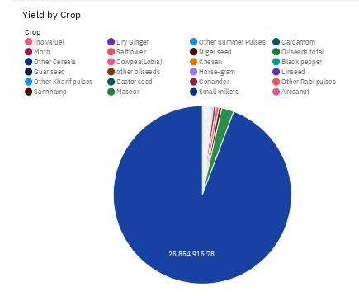

**Crop Coverage: Expansive Insights**

Delve into the vast landscape of crop coverage across regions with this informative chart. It paints a comprehensive picture of which crops dominate specific areas. By analysing the distribution of crop areas, you can gain valuable insights into regional agricultural practices.  
This chart is a valuable resource for stakeholders in the agricultural sector. It aids in resource allocation, market planning, and crop diversification decisions. Understanding which crops thrive regions is essential for sustainable and profitable farming. Explore the nuances of crop coverage and make informed decisions to enhance agricultural outcomes.

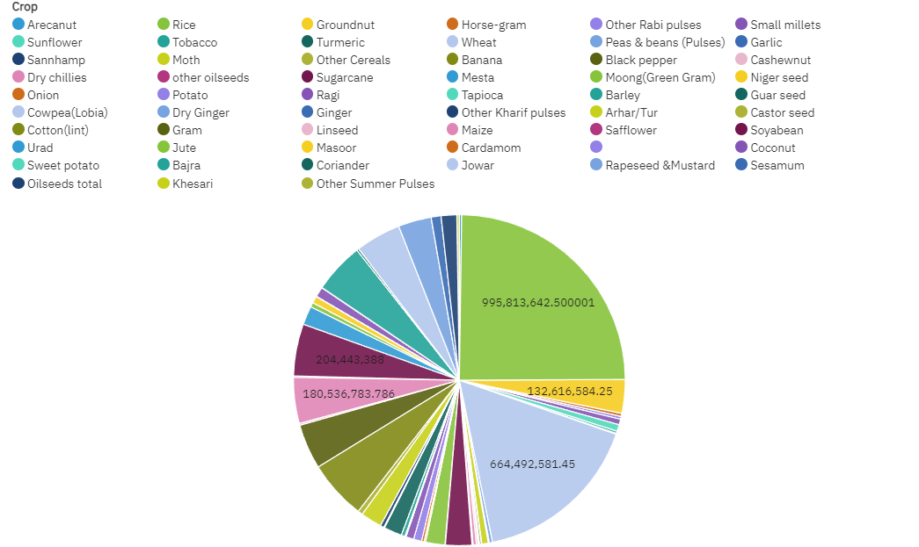

**Dashboard one**

**Description:**  
The Crop Production Insights Dashboard is your gateway to comprehensive agricultural data analysis. This interactive dashboard provides a visual overview of critical agricultural metrics, including production, yield, and crop trends. Explore the production area and yield trends over the years, analyse crop production by state, and gain insights into crop yield variations. This dashboard empowers you to make informed decisions for agricultural excellence.

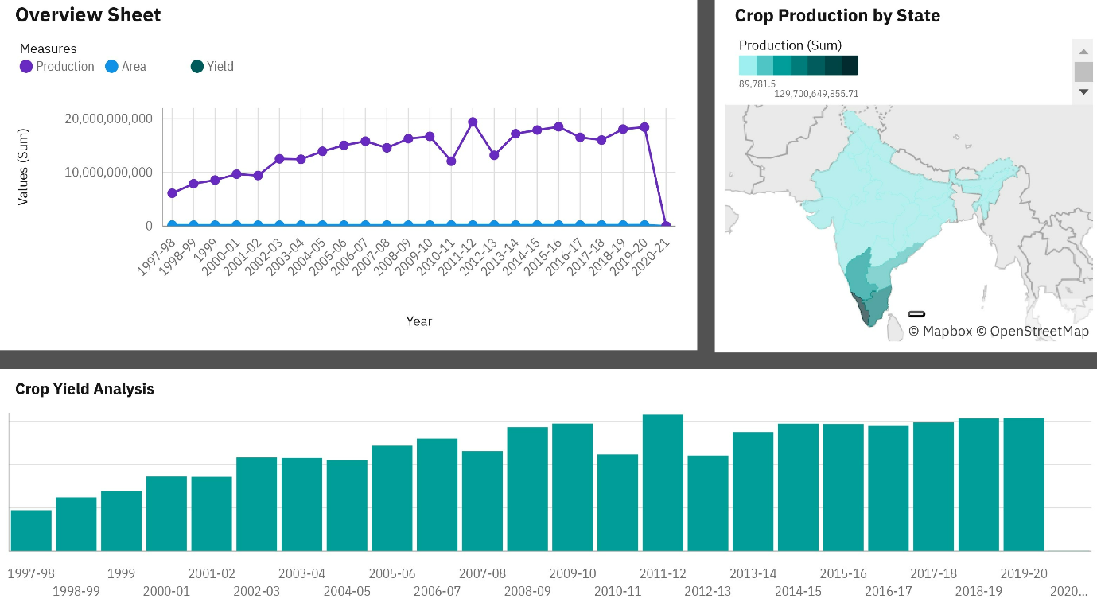

**Dashboard two**

**Description:**  
The State-wise Production Analysis Dashboard is a powerful tool for delving into state-level agricultural insights. With the ability to select specific states, crops, and years, you can analyse production trends with precision. The production by year line chart offers a dynamic view of production over time, while the crop production maps visualize state-wise crop distribution. Additionally, the crop yield analysis provides valuable data to optimize agricultural strategies.

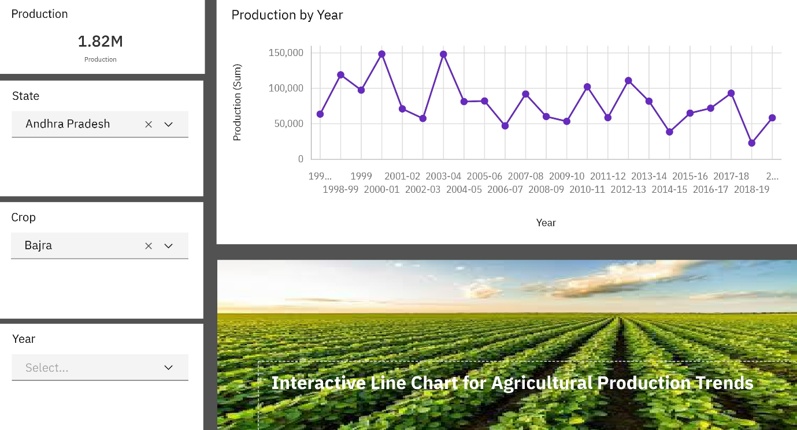

**Dashboard three**

**Description:**  
The Yield Trends and District Analysis Dashboard empowers you to explore in-depth yield data. By selecting states, years, seasons, and crops, you can uncover yield trends and variations at the district level. The line column chart displays district-wise yield, enabling you to spot optimization potential. Dive into the colourful mosaic of India's agricultural districts and discover actionable insights for boosting productivity.

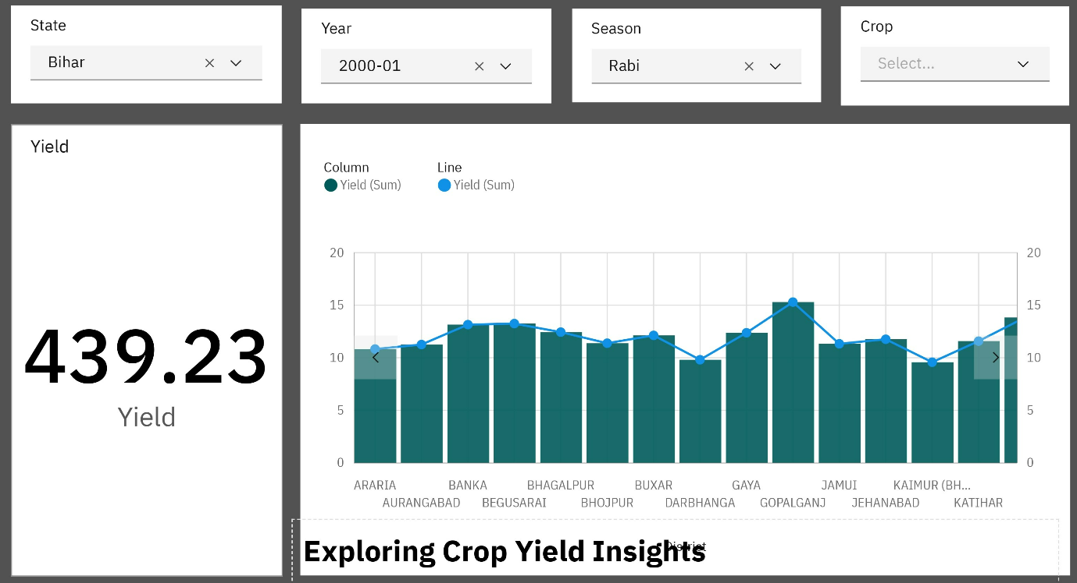

**Story:**

The "Agriculture Insights for Informed Decisions" story unfolds the rich tapestry of India's agricultural landscape, where data cultivates wisdom. This story navigates through captivating visualizations, powered by IBM Cognos, to decode intricate patterns governing crop production. Our mission is to uncover hidden dynamics, spotlight pivotal shifts, and empower data-driven decision-making for a thriving agricultural sector.

**Section 1: Analysing Seasonal Yield Variations of Key Crops**

* **Description:** Dive into the fascinating world of seasonal yield variations. This section compares the performance of key crops across different seasons. Farmers utilize this data to optimize planting and harvesting schedules for peak productivity. Explore the data-driven secrets behind seasonality in agriculture.

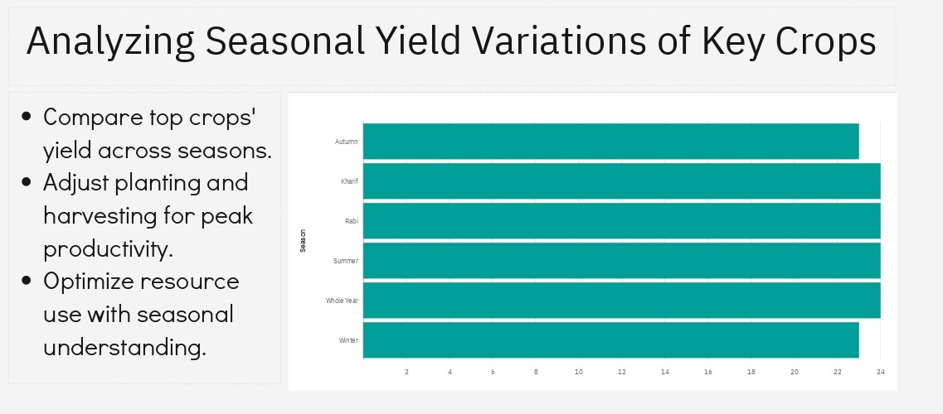

**Section 2: Building Resilience Through Crop Diversification**

* **Description:** Discover the strength of crop diversification in ensuring agricultural stability. This section highlights how diverse crops stabilize production over time, shielding against market fluctuations. Learn why diversification is a strategic choice for a resilient agricultural landscape.

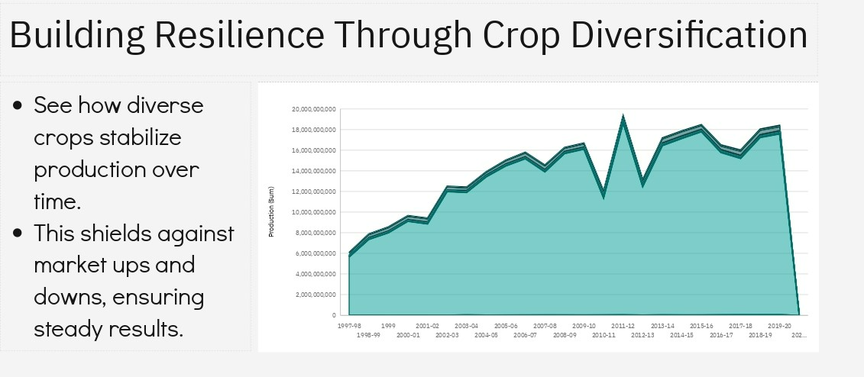

**Section 3: Top Yielding Districts Analysis**

* **Description:** Turn your attention to the districts that excel in crop yields. This section highlights the top yielding districts and analyses yield differences among regions. By understanding these variations, you can guide local strategies for better agricultural productivity.

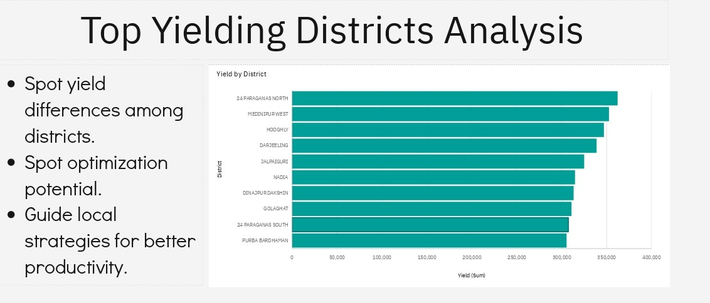

**Section 4: State-wise Crop Yield Analysis**

* **Description:** Uncover regional crop strengths in this section. By comparing yields across states, you can pinpoint areas of crop excellence. These insights inform strategies for maximizing agricultural productivity at the state level.

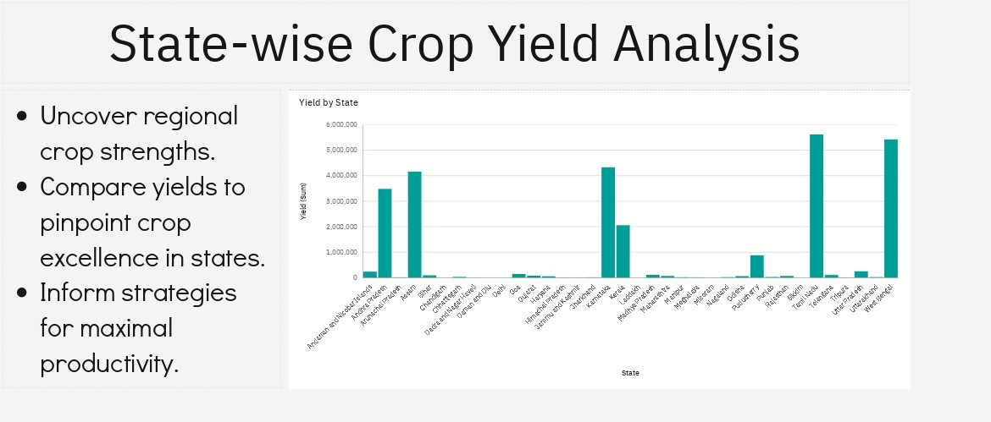

**Reports:**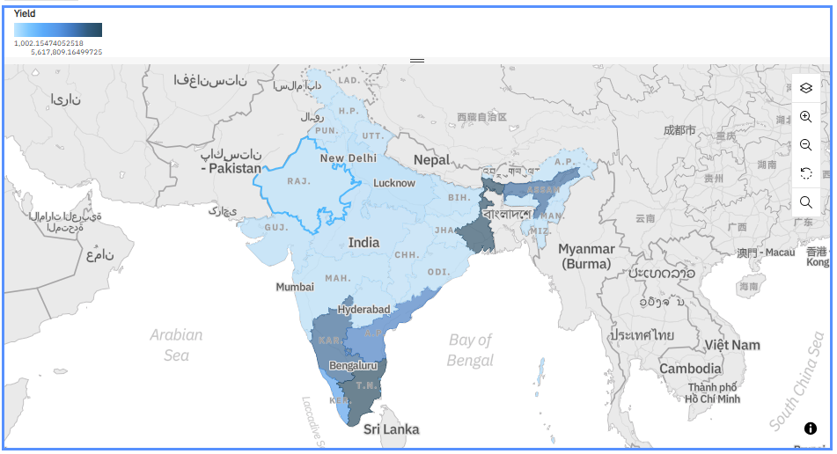

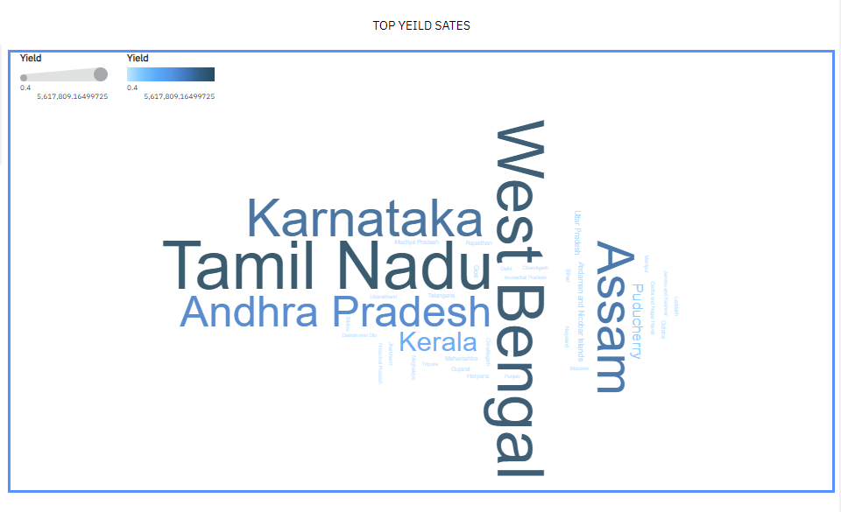

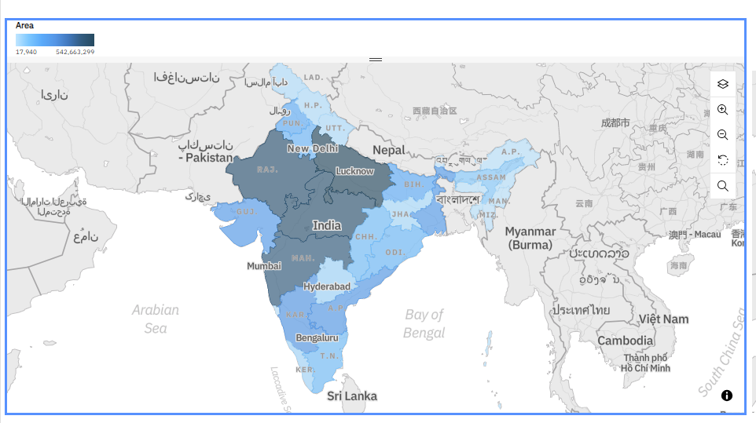

**Inferences based on the analytics and research:**

We can notice that agricultural land distribution is not even across the country.

The cluster which has the largest agricultural land like Madhya Pradesh, Maharashtra are the poor performers in overall yield.

The states that have comparatively less agricultural land area like Tamilnadu, West Bengal etc... have shown better performance in yield.

**Reason for this unbalance Area vs yield pattern:**

We can notice that climate based agricultural sowing pattern is not even across the country.

The cluster which has the largest agricultural land like Madhya Pradesh, Maharashtra sow the crops only during Kharif season.

The states that have comparatively less agricultural land area like Tamilnadu, West Bengal etc... sow the crops during entire year

This uneven sowing pattern and limited climate sowing is the main reason for the uneven yield stat across the nation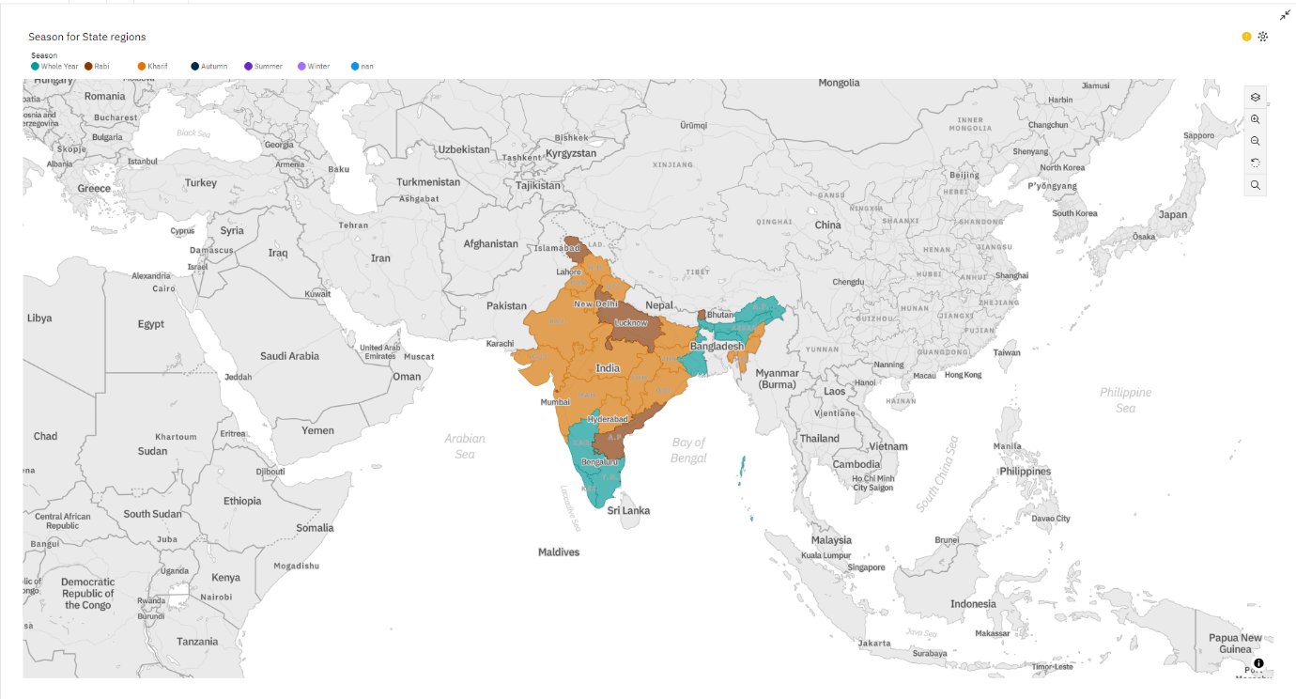

**Conclusion**

In this comprehensive analysis of India's agricultural landscape, we have unveiled a multitude of insights and trends that shape the nation's farming sector. Our journey through the vast expanse of agricultural data has revealed valuable information for farmers, policymakers, researchers, and all stakeholders in the agriculture domain.

We began by exploring the diversity of crops cultivated across different states, offering a glimpse into India's agricultural richness. This knowledge aids in recognizing regional strengths and formulating strategies for optimal productivity.

Next, we delved into the world of yield trends, dissecting how different states perform in terms of crop productivity. These insights are invaluable for understanding which states excel in specific crops and can inform resource allocation and decision-making.

Our analysis also spotlighted the top districts consistently achieving remarkable crop yields, highlighting their pioneering methods and favourable conditions. These champions serve as beacons of agricultural excellence, guiding others toward increased productivity.

Diving into the harmonious world of crop yields, we uncovered how various crops perform across different seasons and regions. This knowledge equips farmers and policymakers with essential information for sustainable farming practices and resource optimization.

Lastly, we explored the expansive insights of crop coverage, providing a comprehensive view of which crops dominate specific regions. This information aids in resource allocation, market planning, and crop diversification.

While our analysis is based on a robust dataset, it is essential to acknowledge its limitations, such as missing data for certain crops and null values. Despite these challenges, we have strived to provide meaningful and actionable insights using the available dataset.

In conclusion, our journey through India's agricultural data has illuminated pathways to enhance productivity, maximize yields, and foster sustainable farming practices. We hope these insights empower stakeholders across the agricultural spectrum to make informed decisions, contributing to the growth and prosperity of India's farming communities.

**References**

Refer our Argo-Analytical-Hub website:

https://innov8ibm.azurewebsites.net/

Explore India's agriculture, one data point at a time! 🌱 #AgroAnalyticsHub